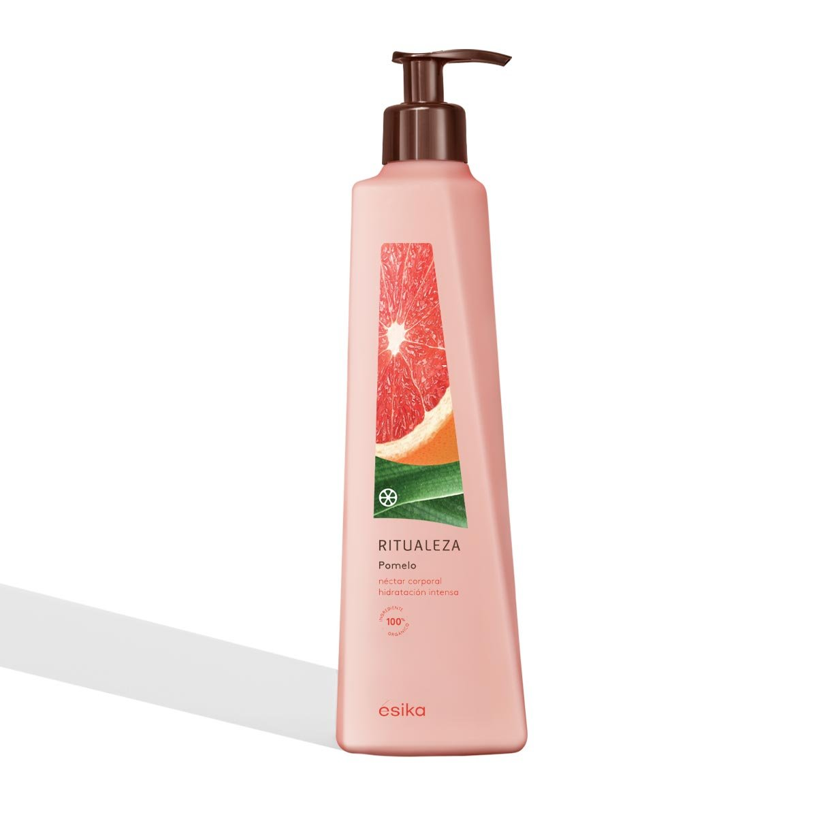Crema corporal Ritualeza Pomelo, 400 ml

**S/ 54.90**

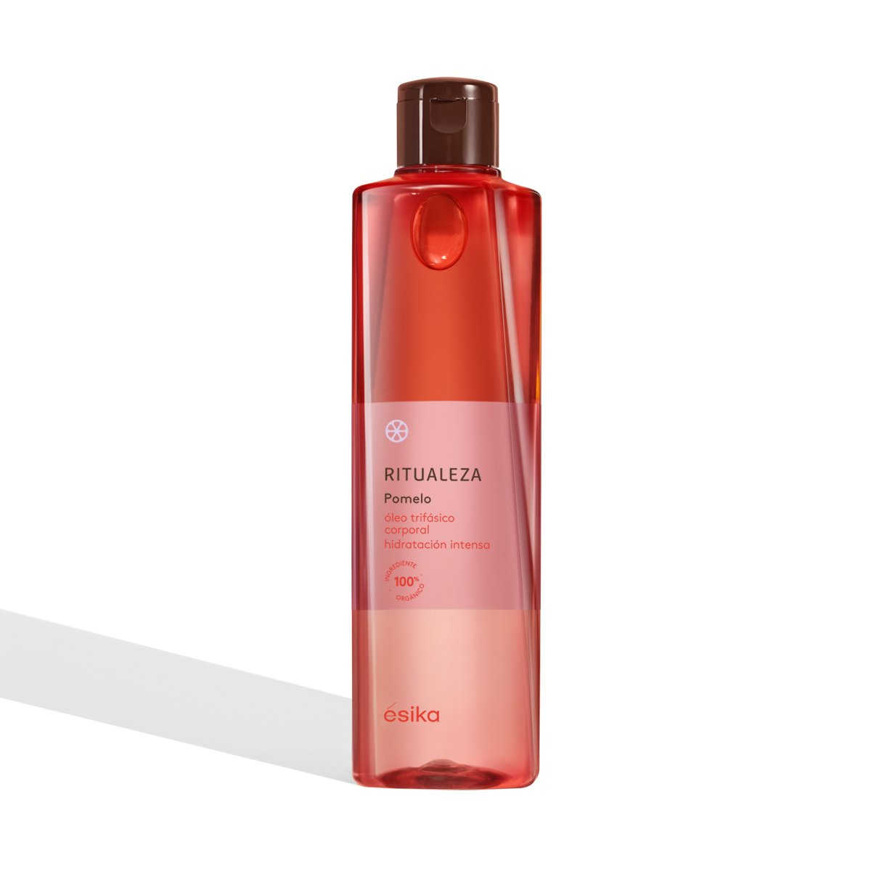  
Óleo corporal Ritualeza Pomelo, 182 ml

~~S/ 70.00~~**S/ 66.90**

Óleo corporal Ritualeza Pomelo, 182 ml

~~S/ 70.00~~**S/ 66.90**

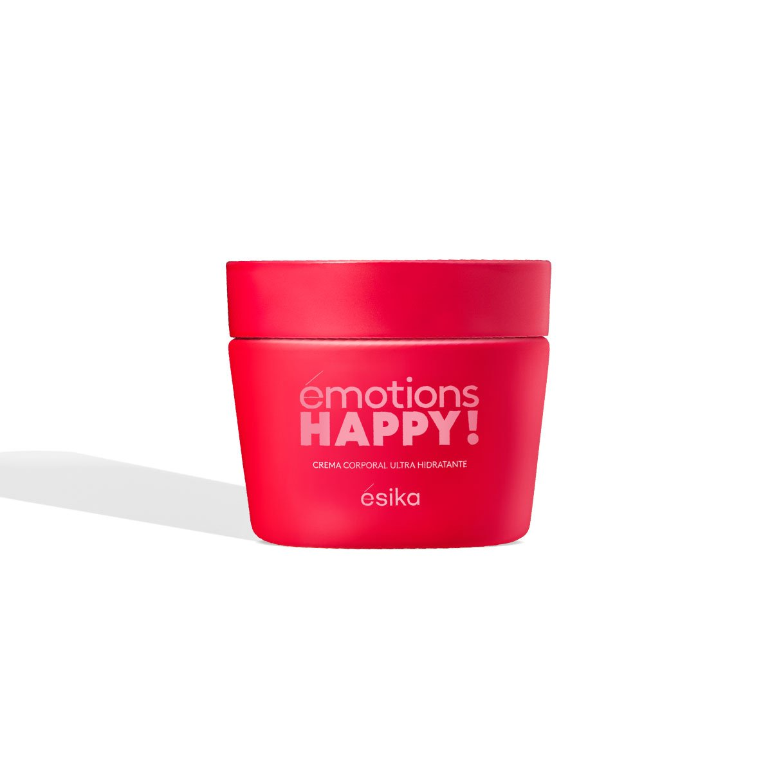émotions HAPPY! Crema corporal

~~S/ 54.00~~**S/ 50.90**

  
émotions HAPPY! Exfoliante corporal

~~S/ 48.00~~**S/ 45.90**

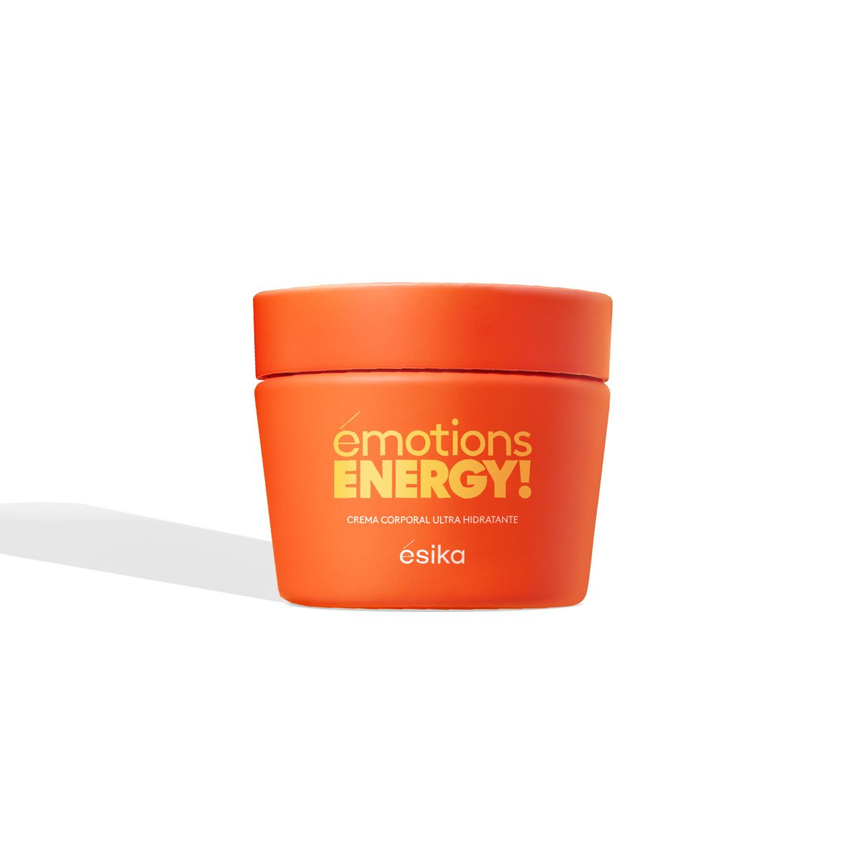  
émotions ENERGY! Crema corporal

~~S/ 54.00~~**S/ 50.90**

émotions ENERGY! Crema corporal

~~S/ 54.00~~**S/ 50.90**

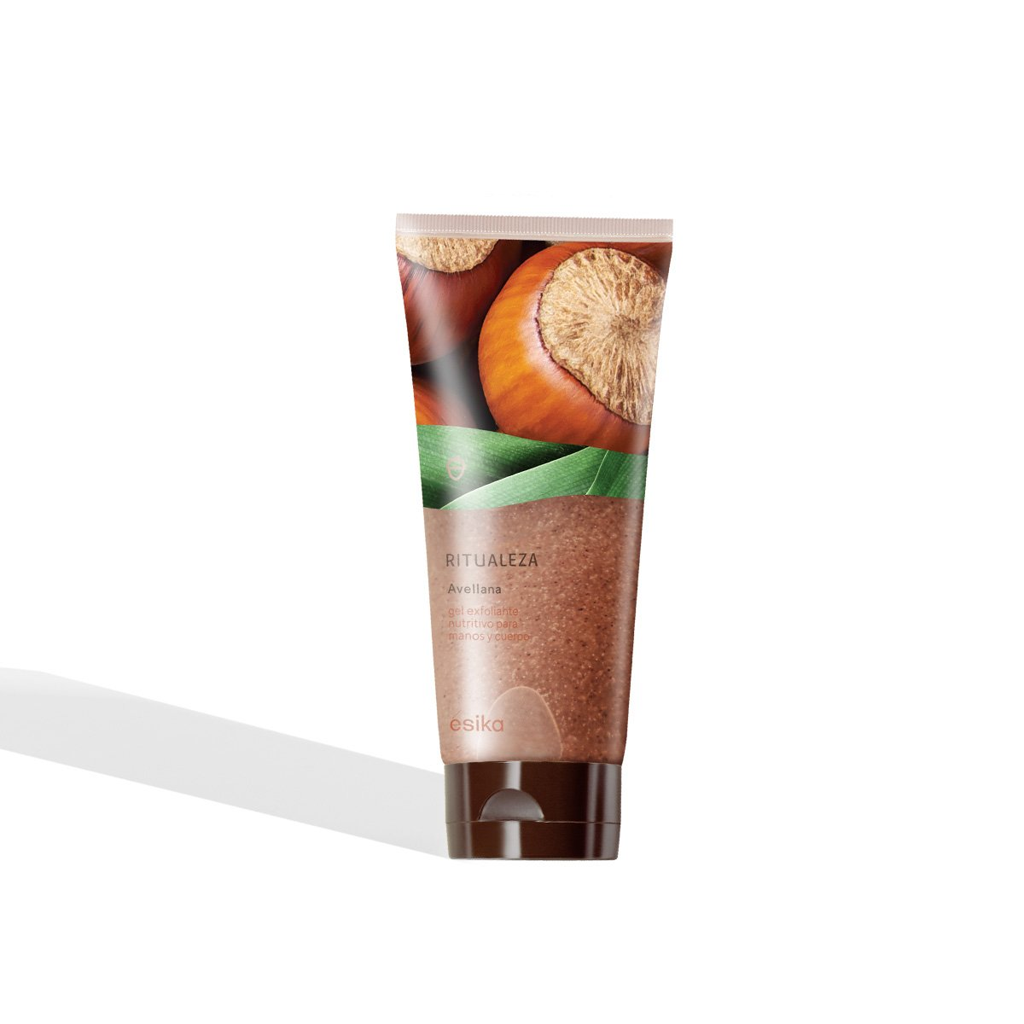Gel exfoliante Ritualeza Avellana, 200 ml

~~S/ 48.00~~**S/ 45.90**